Stellar Importing Cocktail List
Loukatos Mastic & Ouzo

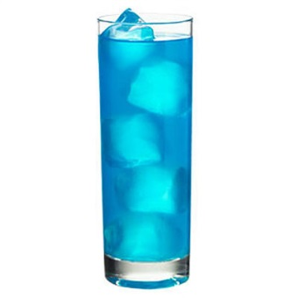
Greek Goddess aka Aegean Sea:
½ oz Loukatos Ouzo
½ oz Blue Curacao
Prep: place all ingredients (into a mixing glass)
Shake with ice. Place into a cocktail glass.

Mojito Mastic:
3oz Loukatos Mastic
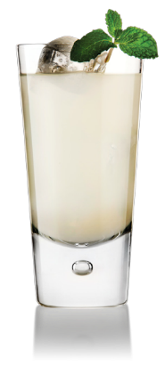
7 Mint Leaves
4 Tbsp of Sugar
1oz Fresh lime juice
1oz Soda
Prep: place mint leaves, sugar and lime into a mixing glass then muddle.
Add all other ingredients and stir with ice.
Garnish with 3 mint leaves.

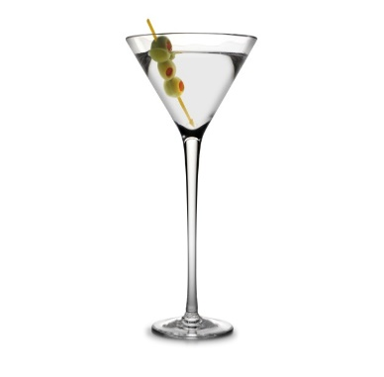
Zorbatini:
1/2oz ounces vodka
1/2 ounce Loukatos Ouzo
Greek olive for garnish.25oz Fresh Lemon juice
Prep: Pour the ingredients into a cocktail shaker filled with ice.
Shake well. Strain into a chilled cocktail glass.
Garnish with a Greek olive.

Stellar Importing
718-747-2171
sam@stellarimports.com

Stellar Importing Cocktail List
Loukatos Mastic & Ouzo

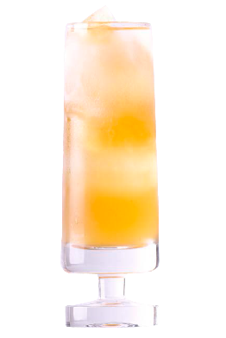
Ouzo Martini:
2oz Loukatos Ouzo
4oz Orange Juice
4oz Pineapple Juice
2oz Vodka
1 tsp Fresh Lime Juice
2 Lime Slices
Prep: place all ingredients into a pint glass with ice and shake until ice cold.
Strain into a martini or cocktail glass and garnish with a 2 Lime Slices.

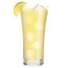
Lemon Ouzo-Ade:
4oz of Loukatos Ouzo
4oz cup of Simple Syrup
3 Fresh Lemons
Prep: place 3 lemons into mixing glass then muddle. Add all ingredients with ice
and shake. Pour into pint glass and serve with lemon garnish.

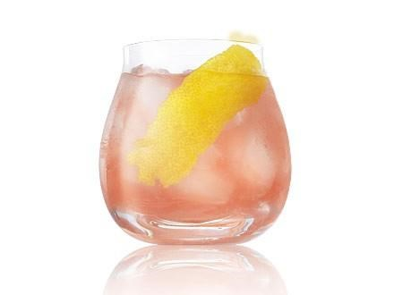
Di Roberto:
1.5oz Loukatos Mastic Liquor
1oz Aperol
1/2oz Vanilla syrup
2 Tsp. Lime juice
Rosemary
Prosecco
Prep: lightly muddle all ingredients (except Prosecco) in a mixing glass and shake with ice.
Strain over new ice into a cocktail highball glass.
Top with Prosecco. Garnish with a Rosemary spring.

Stellar Importing
718-747-2171
sam@stellarimports.com

